**Tutorial #3**

***Parametric study (Multi-dimensional sampling) of advanced tailorable composite laminates (Abaqus)***

February 2024

Bangde Liu & Xin Liu



C:\Users\kotharit2\AppData\Local\Microsoft\Windows\INetCache\Content.MSO\D150AE7A.tmp

### Problem Statement

We study a clamped six-layer panel subjected to a uniform force on the left and right edge (*p* = 1 N/mm) as shown in Fig. 1. The layer thickness is 0.127 mm each and the lamina properties are E1 = 37e3 MPa, E2 = E3 = 9e3 MPa, G12 = G13 = 4e3 MPa, G23 = 4e3 MPa, nu12 = nu13 = nu23 = 0.28.

400 mm

400 mm

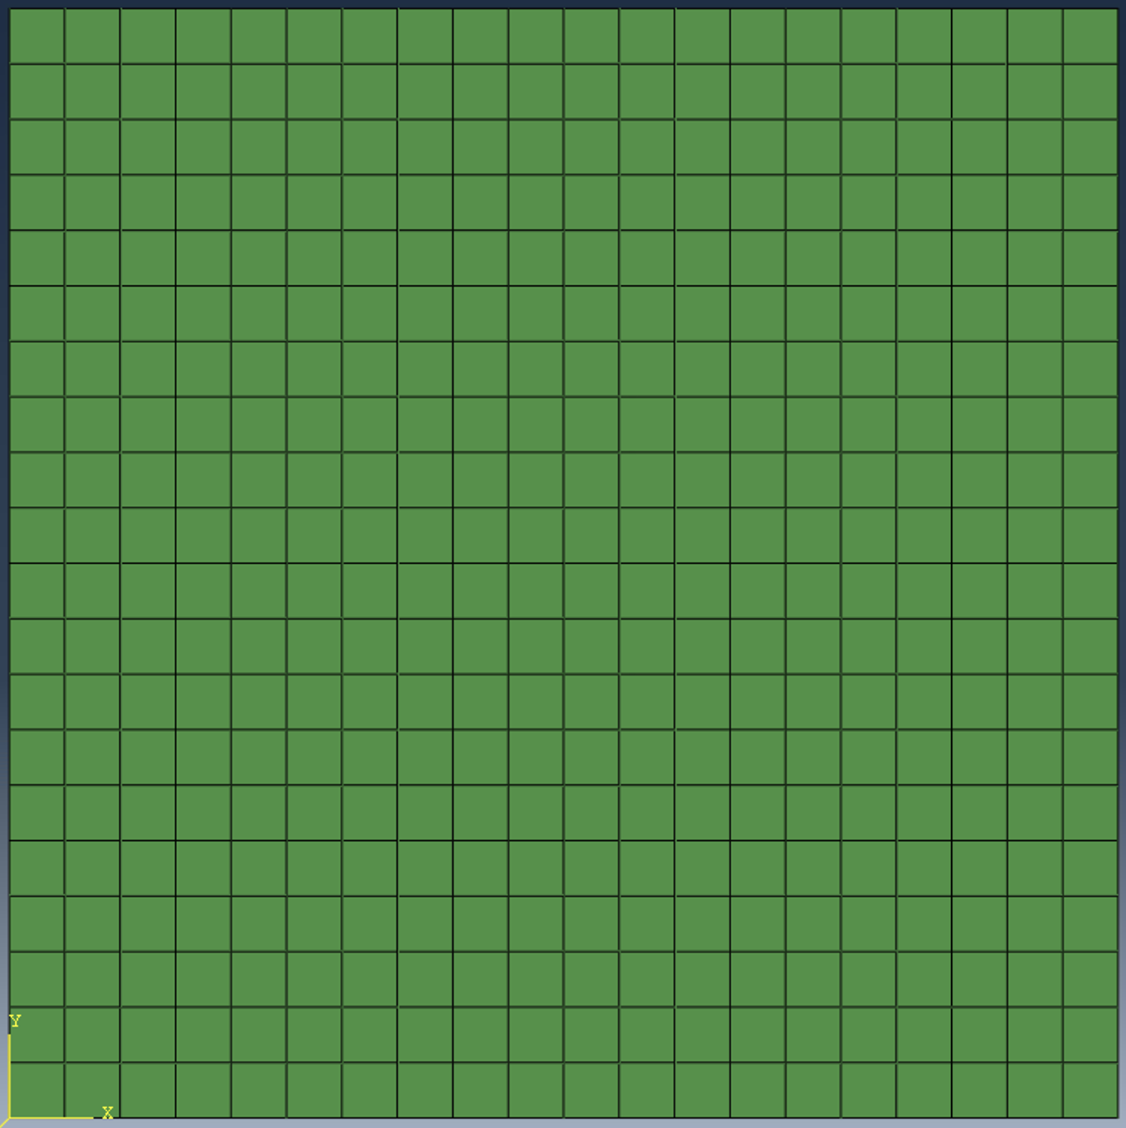

b

h

*x*

y

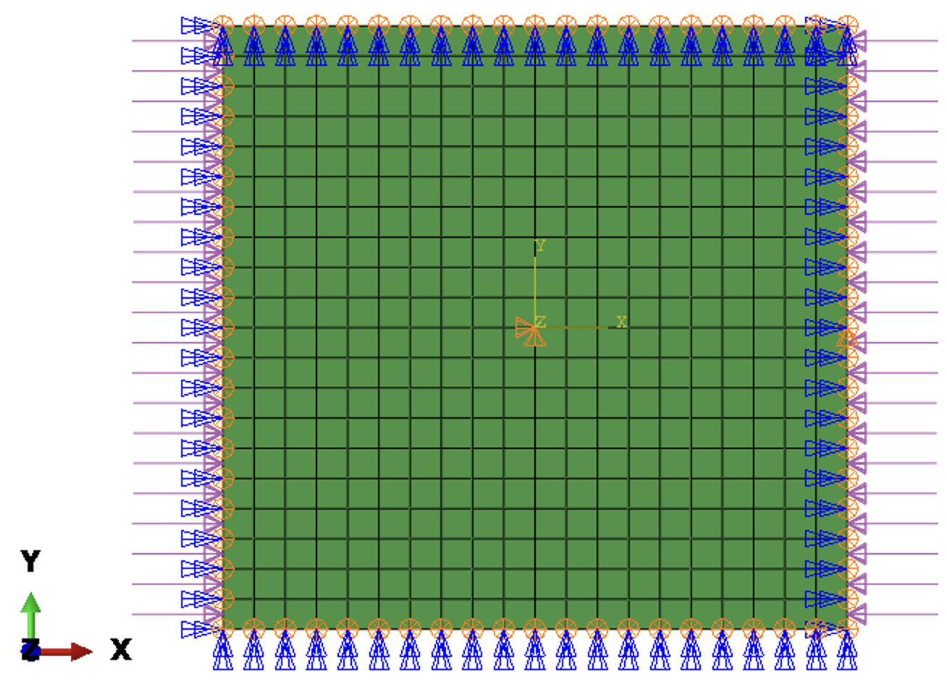

(a) Boundary conditions and loading conditions (b) Dimensions of the plate

Fig. 1 Plate

The laminate has six layers and fiber angles:

1st layer: $0^{∘}$

2nd layer: $θ\left(x\right)=2\left(v_{2}-v_{1}\right)\left|\frac{x}{B}\right|+v_{1}$

3rd layer: ${90}^{∘}$

where B is the width of the plate and equal to 400 mm in this example. The fiber angle orientation for layer 1 and layer 3 are 0o and 90o respectively. The $v_{1}$ and $v_{2}$ are the design parameters to be optimized. In this example, we assume $v_{1}=0$ and $v_{2}=0$ as the initial value, $v_{1}$ ∈ [0, 90], $v_{2}$ ∈ [0, 90]. The fiber path of the first layer of advanced tailorable composite laminate is plotted in Fig. 2.

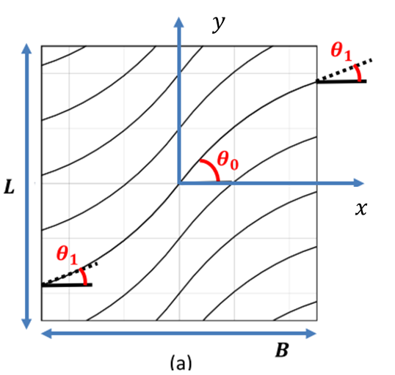

Fig. 2 Fiber Path of the first layer

### Open the CAE model and set current working directory

* Open the CAE model in the path “Plate/CAE model/plate400.cae”.

Fig. 3 Open CAE model

* Set the working directory to “Plate/PS-multi-dim” folder.

Fig. 4 Set work directory

### Define Fiber angles

* Plug-ins >ATC> Define fiber angles. Go to Plug-ins in Abaqus CAE. Click on ATC, and then on Define fiber angles.

Fig. 5 ATC Plug-in

* Define composite lamina with fiber orientation using one-line expression. Layer 1 entries for this example are as in Fig. 6. Layer 2 entries are as shown in Fig. 7. Layer 3 entries are as shown in Fig. 8.

Fig. 6 Layer 1

Fig. 7 Layer 2

Fig. 8 Layer 3

* Define a composite laminate. Click the “Layup” Button. Use the Layup text field in this window to specify layup. Brackets ‘[‘and ‘]’ are a must here and ‘s’ stands for symmetry.

Fig. 9 Layup

* Click the “Define” Button to assign values to design variables. Initial values for fiber angle variables are as specified in Fig. 10.

Fig. 10 Defined Variables

* Click Done on Define fiber angles dialog box to close the window. Note that this step must be completed so that the code will store all the design setups of the laminate.

### Steps

* Plug-ins >ATC> Steps

Fig. 11 Steps

* Give an arbitrary Step name. Select the name of the created job .inp file from the working directory\. The ‘abq_get_result.py’ is the post-processing python script name. The post-processing arguments are specified as in Fig. 12. The ‘abq_result.dat’ shall be the result data file. Click Done.

Fig. 12 Defining post-processing steps

### Parametric Study (Multi-dimensional sampling)

* Plug-ins >ATC> Parametric Study> Multi-dimensional sampling

Fig. 13 Parametric Study Plug-in

* For this example, we use lower bounds and upper bounds as 0,90 with 2 partitions and 0, 90 with 2 partitions for v1 and v2 respectively, as in Fig. 14. Click Done.

Fig. 14 Parametric study box

* The parametric analysis is carried out in the command window, as in Fig. 15.

Fig. 15 End of parametric study

* When finished, this window closes itself and eigenvalue can be viewed in vs_design_ps_tabular.dat in the working directory. (l2v1 means variable $v_{1}$ in layer 2)

Fig. 16 Tabulated eigenvalue

* Other result formats can also be found in the current working directory, as in Fig. 17.

Fig. 17 Other formats